2V (E-Mon™) CT Adapters - Installation Instructions
NOTE: There are TWO different Adapter Boards. One is for the PowerScout 3HD and the other will work in the PowerScout 12HD, 24HD, and 48HD. The PS 3HD circuit board is blue and the PS 12HD, 24HD, & 48 HD circuit board is green.
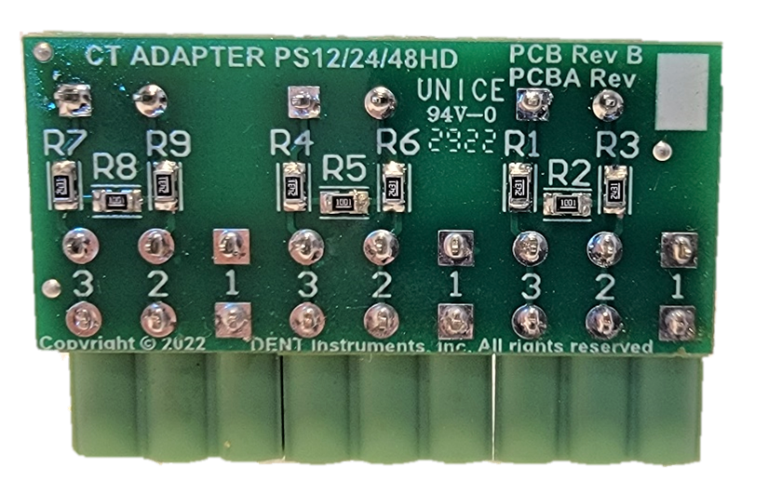
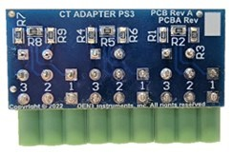

PowerScout™ 3HD PowerScout™ 12HD, 24HD, & 48HD

Adapter Installation

PS3HD Meter (DIN Rail and Wall Mount)
The PS3HD adapter card provides the mating connectors for all 3 Current Transformers from an E-Mon™ meter. If included, remove the three existing CT connectors from the PowerScout 3HD and install the adapter.
- Remove Existing CT Connectors 2. Plug-in Adapter 3. Connect 2 volt CTs
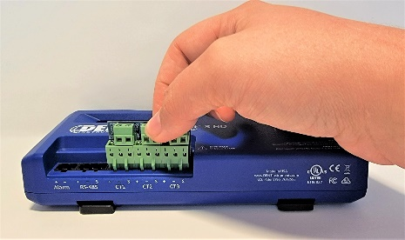
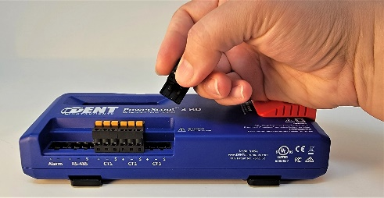
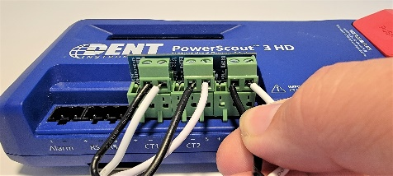

Corresponding CT channels, 1, 2, & 3, are labeled in silkscreen next to each terminal block along with polarity markings. Note that the E-Mon™ CT lead colors are REVERSED from standard DENT Instruments CT colors (i.e., E-Mon™ black is DENT white, and E-Mon™ white is DENT black). The black wire from the E-Mon™ CT will need to be connected to the positive(+), terminal while the white E-Mon™ CT wire connects to the negative(-) terminal as shown in the photo above.

PS48HD, PS24HD, PS12HD Meters
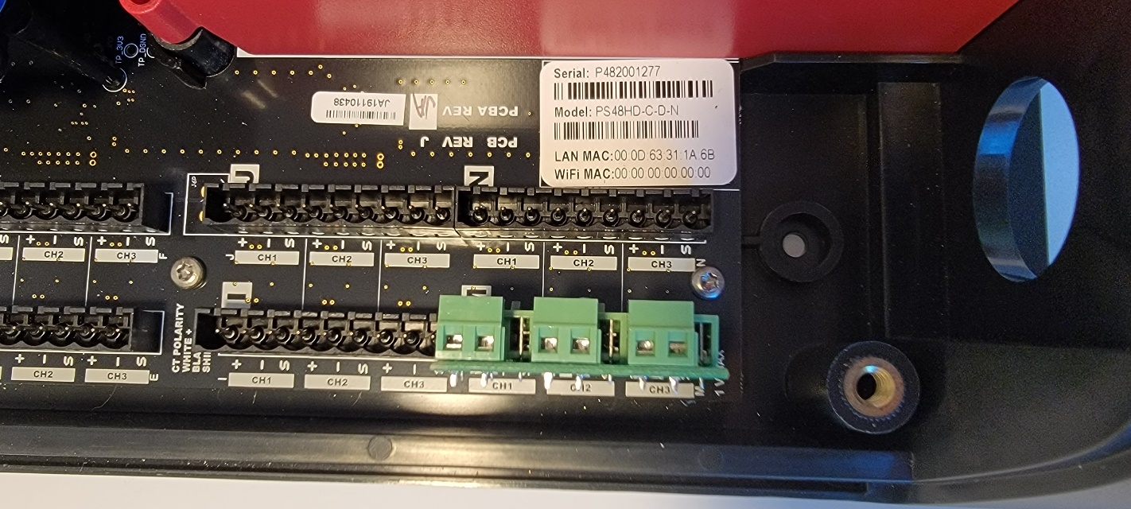
The PS12/PS24/PS48HD adapter card provides the mating connectors for all 3 CT channels on a meter element. Three, two-pin screw terminal blocks are provided, one for each E-Mon™ CT. Corresponding CT channels are labeled in the silkscreen next to each terminal block along with polarity markings.

Note that the E-Mon™ CT lead colors are REVERSED from standard DENT Instruments CT colors (i.e., E-Mon™ black is DENT white and E-Mon™ white is DENT black). The black wire from the E-Mon™ CT will need to be connected to the positive(+), terminal while the white E-Mon™ CT wire connects to the negative(-) terminal.

ViewPoint HD™ Update
The CT adapters can be used with older versions of ViewPoint HD by simply entering the default E-Mon™ current rating in the “Range” field on the Meter Setup page.

An easier method is to use the “CT Picker” dropdown menu in ViewPoint HD. Version 2.16 and above supports the E-Mon™ CTs. On the Meter Setup page:
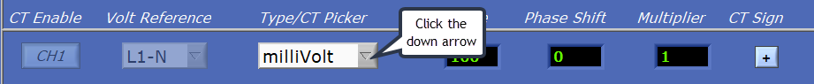
Clicking the down arrow launches the “CT Picker” list. Scroll down to the 2V E-Mon™ CTs and choose the amperage of the CTs that will be reused.
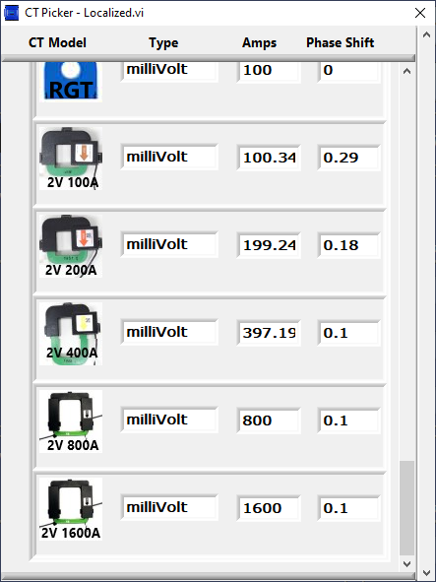
Note that the “Type” will still say “millivolt” as that refers to how the meter processes the signal from the adapter card.
Also, the E-Mon™ CTs are made more accurate by using the CT ratio corrections and CT Phase shift offsets found in the CT Picker. For the 100A CT use the 100.34A selection, the 400A CT uses the 397.19A selection and so on.

The latest version of ViewPoint HD that supports the new CT types can be found at https://www.dentinstruments.com/software-download/powerscout-hd-thanks/ and follow these instructions to perform a clean installation:

NEW INSTALLATIONS: For Users Where No Prior Version of ViewPoint HD Has Been Installed
- Copy the “MEDIA DISTRIBUTION” folder to your local hard drive. Installations attempted from Thumb Drives or across a Network may not be successful.
- Locate and double-click on the “Run Me to Install ViewPoint HD.bat” batch file (highlighted below).
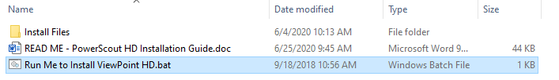
The batch file installs both the application and drivers needed for ViewPoint HD. The batch file will create a folder called “ViewPoint HD” on the root of the C drive. This folder location will contain customization features for your viewer and be the default location for configuration files and retrieved log data.
- Follow the prompts <NEXT>, <FINISH>. This process should take about 1 minute.

SOFTWARE UPDATE: For Users with ViewPoint HD Software Already Installed
Installing ViewPoint HD “over the top” of an existing Viewer may not replace all the support files with the current version. Therefore, additional steps must be taken prior to attempting to install an updated version of ViewPoint HD.
Before running the installer, take the following steps:
- Locate the ViewPoint HD Application within Windows “Program and Features”
  - Right-click on the program in the Windows Start menu and select “Uninstall”
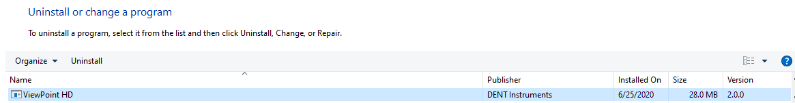
- Delete the “ViewPoint HD” folder from C:\ drive

- Proceed with the steps listed under NEW INSTALLATIONS above.

  - Your installation will skip the installation of drivers.

  - ViewPoint HD will auto-launch if the installation is successful.

Open ViewPoint HD (or, if already open, close the ViewPoint HD application and then reopen). In ViewPoint HD, go to the Meter Setup and, in any channel, select “Type/CT Picker” drop-down arrow. This will bring up a selection table with the E-Mon™ 2V output CTs now shown as available options with the phase shifts set correctly for the 100A, 200A, and 400A ranges and estimated for the 800A and 1600A CTs.

